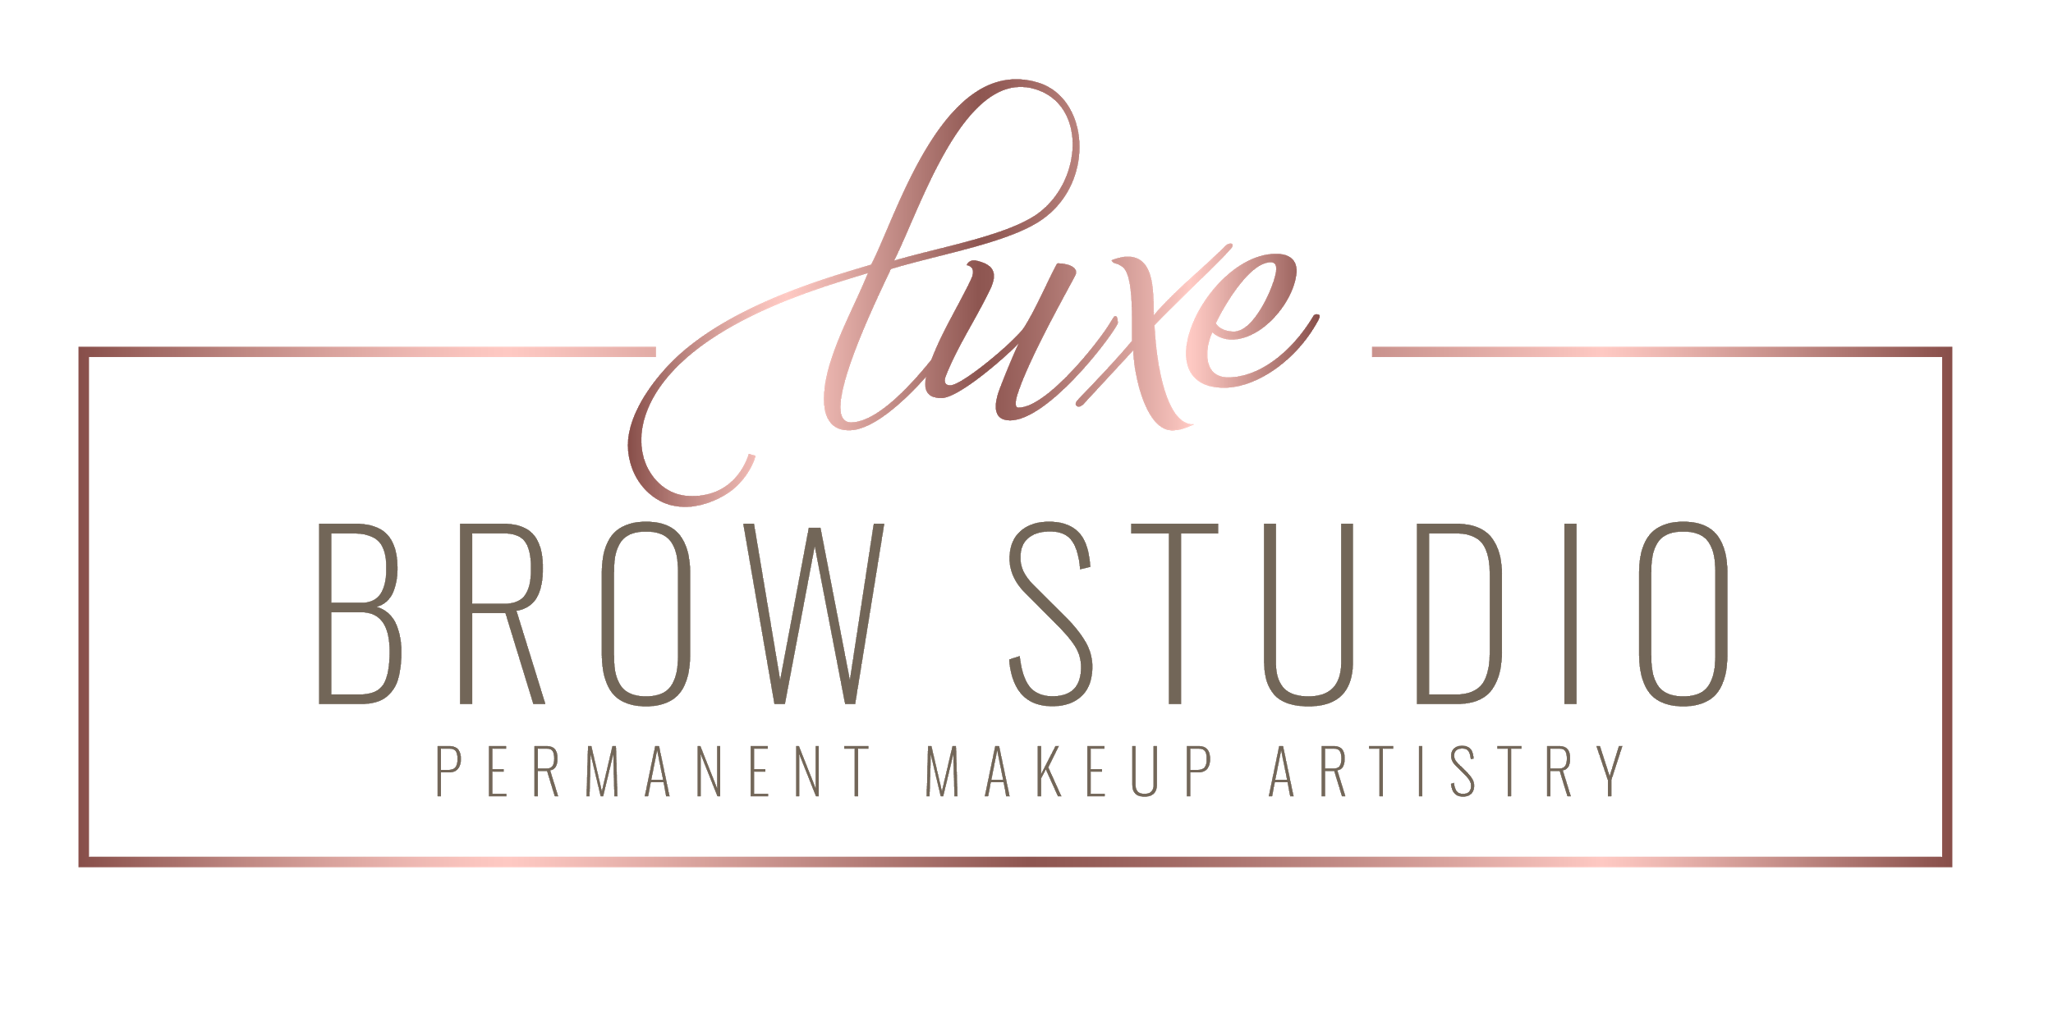
INFORMED CONSENT COVID-19 PANDEMIC

I understand that I am opting for a service that is not urgent and not medically necessary. I also understand that the coronavirus disease (COVID-19) has been declared a worldwide pandemic by the World Health Organization. I further understand COVID-19 is extremely contagious. State and federal health agencies recommend social distancing. I recognize that Sophia at Luxe Brow Studio is closely monitoring this situation and has put in place reasonable preventive measures targeted to reduce the spread of this virus. However, given the nature of the virus, I understand there is an inherent risk of becoming infected with COVID-19 if I proceed with this elective service. Accordingly I acknowledge and assume the risk of becoming infected with COVID-19, and any variation or mutation thereof, through this elective service and I give my express permission for Sophia at Luxe Brow Studio to proceed with the same. This consent applies to any follow up or additional services in the upcoming months. I understand that even if I have been tested for COVID-19 and received a negative test result, the tests may not have detected the virus or I may have contracted COVID-19 after the test. I will not hold this business and professional offering the service responsible for any liability related to COVID-19 and any variation or mutation thereof. I have been given the option to defer my service to a later date. However, I understand all the risks including those noted herein and I would like to proceed with this service. I have been offered a copy of this consent form. I understand the explanation and consent to the procedure.

Client Signature & Date:

Provider’s Signature & Date:

